**PIZZA SALES SQL QUERIES**

**- Dhinagaran P**

**A. KPI’s**

**1. Total Revenue:**

SELECTSUM(total_price)ASTotal_RevenueFROMpizza_sales;

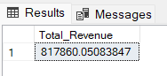

**2. Average Order Value**

SELECT(SUM(total_price)/COUNT(DISTINCTorder_id))ASAvg_order_ValueFROMpizza_sales;

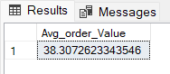

**3. Total Pizzas Sold**

SELECTSUM(quantity)ASTotal_pizza_soldFROMpizza_sales;

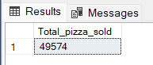

**4. Total Orders**

SELECTCOUNT(DISTINCTorder_id)ASTotal_OrdersFROMpizza_sales;

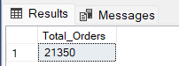

**5. Average Pizzas Per Order**

SELECTCAST(CAST(SUM(quantity)ASDECIMAL(10,2))/

CAST(COUNT(DISTINCTorder_id)ASDECIMAL(10,2))ASDECIMAL(10,2))

ASAvg_Pizzas_per_order

FROMpizza_sales;

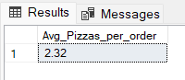

**B. Daily Trend for Total Orders**SELECTDATENAME(DW,order_date)ASorder_day,COUNT(DISTINCTorder_id)AStotal_orders

FROMpizza_sales

GROUPBYDATENAME(DW,order_date);

***Output:***

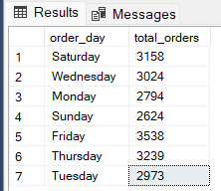

**C. Hourly Trend for Orders**

SELECTDATEPART(HOUR,order_time)asorder_hours,COUNT(DISTINCTorder_id)astotal_orders

frompizza_sales

groupbyDATEPART(HOUR,order_time)

orderbyDATEPART(HOUR,order_time);

***Output***

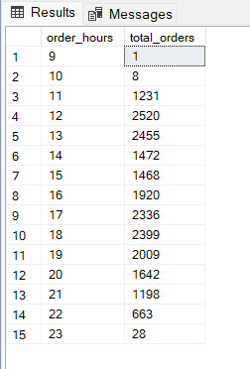

**D. % of Sales by Pizza Category**

SELECTpizza_category,CAST(SUM(total_price)ASDECIMAL(10,2))astotal_revenue,

CAST(SUM(total_price)* 100 /(SELECTSUM(total_price)frompizza_sales)ASDECIMAL(10,2))AS PCT

FROMpizza_sales

GROUPBYpizza_category;

***Output***

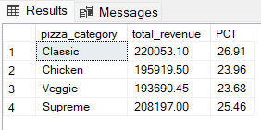

**E. % of Sales by Pizza Size**

SELECTpizza_size,CAST(SUM(total_price)ASDECIMAL(10,2))astotal_revenue,

CAST(SUM(total_price)* 100 /(SELECTSUM(total_price)frompizza_sales)ASDECIMAL(10,2))AS PCT

FROMpizza_sales

GROUPBYpizza_size

ORDERBYpizza_size;

***Output***

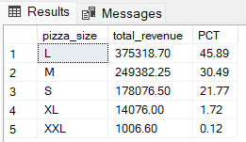

**F. Total Pizzas Sold by Pizza Category**

SELECTpizza_category,SUM(quantity)asTotal_Quantity_Sold

FROMpizza_sales

WHEREMONTH(order_date)= 2

GROUPBYpizza_category

ORDERBYTotal_Quantity_SoldDESC;

***Output***

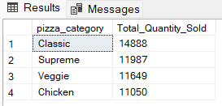

**G. Top 5 Best Sellers by Total Pizzas Sold**

SELECTTop 5 pizza_name,SUM(quantity)ASTotal_Pizza_Sold

FROMpizza_sales

GROUPBYpizza_name

ORDERBYTotal_Pizza_SoldDESC;

***Output***

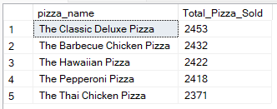

**H. Bottom 5 Best Sellers by Total Pizzas Sold**

SELECTTOP 5 pizza_name,SUM(quantity)ASTotal_Pizza_Sold

FROMpizza_sales

GROUPBYpizza_name

ORDERBYTotal_Pizza_SoldASC;

***Output***

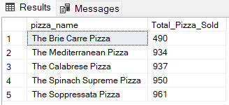

***NOTE***

If you want to apply the Month, Quarter, Week filters to the above queries you can use WHERE clause. Follow some of below examples

SELECTDATENAME(DW,order_date)ASorder_day,COUNT(DISTINCTorder_id)AStotal_orders

FROMpizza_sales

WHEREMONTH(order_date)= 1

GROUPBYDATENAME(DW,order_date);

*\*Here MONTH(order_date) = 1 indicates that the output is for the month of January. MONTH(order_date) = 4 indicates output for Month of April.*

SELECTDATENAME(DW,order_date)ASorder_day,COUNT(DISTINCTorder_id)AStotal_orders

FROMpizza_sales

WHEREDATEPART(QUARTER,order_date)= 1

GROUPBYDATENAME(DW,order_date);

*\*Here DATEPART(QUARTER, order_date) = 1 indicates that the output is for the Quarter 1. MONTH(order_date) = 3 indicates output for Quarter 3.*